

INF1103 Project 1 Report
Date of Submission:
14 October 2026

Name | Admin Number | Email
Matthew | 2603057 | 2603057@sit.singaporetech.edu.sg
Tan Yixi Kimberley | 2604076 | 2604076@sit.singaporetech.edu.sg
Tee Han Sheng | 2603667 | 2603667@sit.singaporetech.edu.sg
Chiam Zhi Ting | 2605365 | 2605365@sit.singaporetech.edu.sg
Kieron | 2605378 | 2605378@sit.singaporetech.edu.sg
David Chan Kwok Jun | 2601849 | 2601849@sit.singaporetech.edu.sg

Link to GitHub: https://github.com/ths2018/26INF1103P5-5

1. Introduction
Hospitals and clinics operate under heavy patient demand, which makes it hard for busy staff to quickly spot patients who need urgent care. Patients may also underestimate their symptoms and seek routine care while their condition worsens in the waiting area. Our application is an AI-assisted symptom triage tool for two groups: patients who are unsure whether their symptoms need a doctor, and nurses who need a quick, consistent urgency assessment.
The patient enters their name, date of birth, gender, symptoms and how long they have had them. The program validates every entry, calculates the age, and builds a prompt for an AI service. The AI asks follow-up questions when information is incomplete, then returns an urgency classification, a certainty level and next-step guidance. Every exchange is saved as a case record that can be searched and exported to CSV or Excel.

Data Flow Diagram
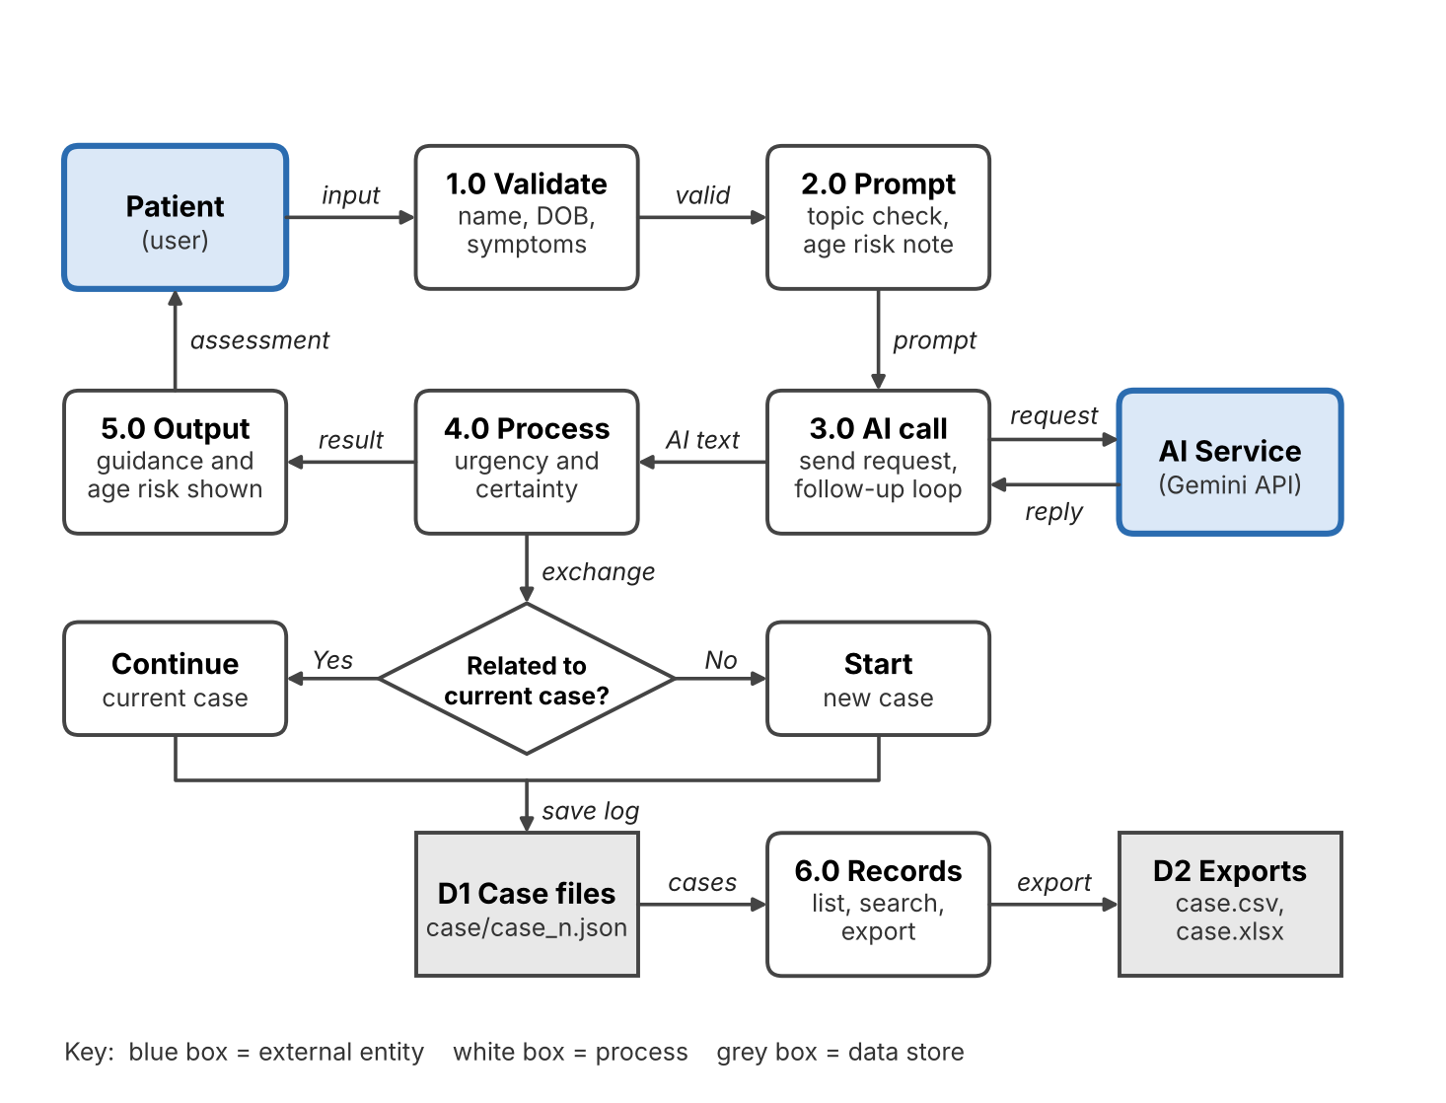
Figure 1- data flow diagram of healthcare assessment chatbot.
A patient's answers pass through validation and a topic check before anything reaches the AI, and every exchange is written to a case file.
- External entities: Patient (user), AI Service (API)
- Processes: 1.0 Validate, 2.0 Prompt, 3.0 AI call, 4.0 Process, 5.0 Output, 6.0 Records
- Decision: Related current case? Yes: continues the current case and No: starts a new one
- Data stores: D1 Cases (JSON), D2 Exports (CSV, Excel)
- Follow-up loop: when the AI asks a question, the patient answers it and the answer goes back through 3.0, repeating until no question remains.
- Records menu: options 2 to 5 skip the AI and go straight to 6.0, which reads D1 and writes D2.

Data Structure and Storage Design
Each case is stored as one JSON file named <case_id>.json. Exports are generated from these files on request. Check the field names below against your data_manager.py before submitting.
File | Format | Purpose
case/case_<n>.json | JSON | One conversation (case) with its status and all logged exchanges
case/case.csv | CSV | Flat copy of all logs for spreadsheets and reporting (UTF-8, opens correctly in Excel)
case/case.xlsx | Excel (.xlsx) | Same data, colour-coded by urgency, opened automatically after export
Case record structure
Field | Type | Description
case_id | string | Unique case identifier, also the file name
status | string | Open while active, closed when finished
created, closed | string | Start and end time of the case (ISO format)
logs | list | One entry per exchange, in order
logs[].timestamp | string | Time of the exchange (ISO format e.g. 2026-1013T18:32:05)
logs[].user_input | string | The prompt or answer the patient sent
logs[].ai_response | string | The AI’s reply, including urgency, certainty and guidance

Patient data collected before the prompt is built
Field | Example | Validation
name | Mary Tan | Letters, spaces, hyphens and apostrophes only
dob | 01/01/2025 | DD/MM/YYYY, not in the future
age | 1 | Calculated from dob
gender | Female | Male or Female (m and f accepted)
symptoms | fever, cough | Comma-separated, at least one
symptom_duration | 1 week | Positive number plus a valid time unit

Exception Handling Matrix
Input errors are caught at the point of entry and asked again in a loop, so invalid data never reaches the AI or the saved files. Keep only the rows your final code really handles, and confirm the AI, file and export rows against ai_manager.py and data_manager.py.
Exception scenario | Possible cause | Detection method | Handling strategy | User outcome
Invalid menu choice | Typo or number outside 1–6 | Input not in the allowed list | Re-prompt in a loop | Told to enter a number from 1 to 6
Invalid name | Empty, digits or symbols | Empty check and isalpha() per character | Re-prompt | Told what is wrong
Invalid date of birth | Wrong format, or a future date | strptime raises ValueError; date compared with today | Re-prompt | Told the DD/MM/YYYY format
Invalid gender or yes/no | Unexpected text | Value not in the allowed list | Re-prompt | Told to enter a valid option
Empty or invalid symptoms | Blank input, only commas | Empty check after splitting on commas | Re-prompt | Told to enter at least one symptom
Invalid symptom duration | Missing number, zero, unknown unit | Split into two parts, isdigit(), unit list | Re-prompt | Told the expected format, e.g. 3 days
Non-health question | Off-topic input | is_health_related keyword check | Polite refusal, no AI call | Asked to ask about a health issue
Empty follow-up answer | Patient presses Enter | Empty-string check | Re-prompt | Told to provide an answer
AI service failure | Network issue, timeout, service down | ask_ai returns None or raises an exception | Safe message, no crash (confirm in ai_manager.py) | Told the service is unavailable
Missing or odd certainty value | AI omits the section or writes 85% | get_certainty regex finds no number or a percentage | Default to 1.0 or convert to 0–1 | None; assessment still shown
Empty search keyword | Blank input | Empty-string check | Message shown, no search | Told the keyword cannot be empty
No matching records | Keyword not found | Empty result list | "No matching records" message | Informed, returned to menu
No saved cases | First run | Empty file list | "No cases saved yet" message | Informed, returned to menu
Corrupt or unreadable case file | Bad JSON, manual edit | load_case returns nothing | Warning shown, File skipped | Other cases still listed
Save failure | Disk full, no permission | Save_case catches OSError | Temp file keeps the old file intact | Told the save failed: earlier data safe
Excel package missing | openpyxl not installed | ImportError caught | Message with the install command: CSV export still works
Export writes failure | File open in Excel, no permission | OSError caught when writing the file | Error message instead of a crash | Told to close the file and retry
File cannot be opened | No default app, file missing | open_file checks the file exits and catches OSError | Message shown, program continues | Told the file could not be opened
Invalid history navigation | Unknown key or no next or previous page | Input is not n, p or q, or page limit reached | Message shown, same page stays | Told the option is invalid

